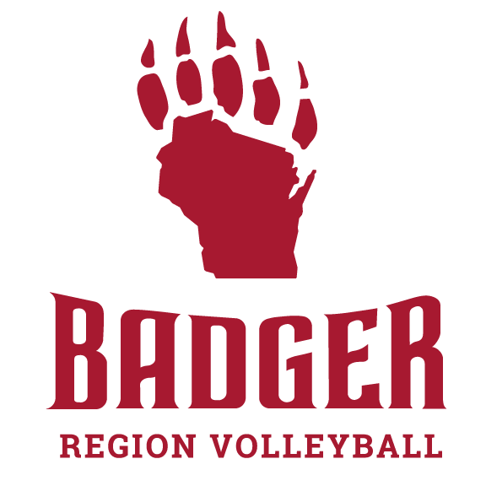**2024 Badger Region Beach Championships Tournament Info.**

Team Check-In **8:30-8:45 a.m**.: All teams should have one member

go to the tournament desk and check-in their team. This is as simple

as letting the desk worker know your team has arrived.

Captains/Coaches Meeting: **8:45 a.m**.: All teams must have at least 1 player attend.

This is where details of the day will be presented and questions can be asked.

Player rules:

Scoring: All games will be played using rally scoring.

Tips: No open hand tips.

Double Contact: Players may double contact a hard driven ball only. No setting the serve.

Let Serves: Let Serves are legal.

Blocking: A block is counted as a team hit.

Foot Digs: Foot Digs are legal.

Setting Over: When the ball is set into the opponents court, the setters shoulders must be "Squared Up" or Perpendicular to the line of flight of the ball.

Time Outs: Each team is allowed two 30 second timeouts per game. Which can be taken by either team prior to a ball being served.

Side Changes: Teams should switch sides of the court after every 7 points in games to 17 or more, and every 5 points for games to 15.

Coaches:

If a team chooses to have a Coach the Coach must have a USAV membership, BG screen and Safe Sport.

They are only allowed to coach during side switches, time outs, and between sets.

Coaches are not allowed to call balls in or out or coach the athletes during play.

Scoresheet/Flip Score:

Since many divisions/pools and sharing courts if a playing team is not around to fill out the tally scoresheet and run the flip score – a spectating member for each team should fill those roles.

Awards:

Winners will receive T-Shirts and Medals while 2nd and 3rd place (if 3rd place match is played will receive Medals.